## Note about this folder

I am going to share this sooner than later, but I am still compiling information. Due to the mixing of unrelated parties, I am going to try and share what I can without disclosing information of unrelated people. Additionally, given the long history of much of this, I have to sort through everything that has been scraped from Discord and other media. This is a living document. I will try, within reason, to alert those involved in reading this to notable updates and when things are uploaded to the folder.

Last Update: Dec 17, 2021

## Notes about witnesses

I am still waiting for permission to name witnesses. Given the open retaliation that is still unaddressed within both metal shop and by the board when I went public with matters, some witnesses had asked not to be named at this time. With the ability to share this information with board members outside of DMS systems where freddy can see, I am asking them again about their willingness to speak on the record. Should a neutral panel be assembled, I will again update them on the status and ask. However, it should be noted that the board waited some time before even asking for information, let alone interviewing anyone, and thus information availability is reduced and witnesses now have to recall things that happened some time ago. This is further complicated by board members deterring me from speaking out at earlier times.

Witnesses TKTK-1 and TKTK-2 are parties to the physical cornering in part of the building. I am still awaiting their permission to name them and if they can speak on the matter due to the duration of time  
Witness Malcolm Galland is party to the “Chick with a Dick” incident on talk

Witnesses Art Givens and Shay Galland are party to the back lot incident on October 3rd. Art Givens has indicated that the board waited over a month before asking about the event, and was unable to recall enough specifics due to the duration of time. However, they did confirm some aspects of the incident and spoke about other matters at length which I will compile into a separate document.

Witnesses TKTK-5 and TKTK-6 are party to the perception of aggressiveness from Freddy

Witness TKTK-7 is party to the aggressiveness of Julie at the metal shop towards anyone that challenges the board narrative of events. I am awaiting the posting of the minutes to seek additional statements from listed attendees. This is a primary concern towards naming witnesses and the lack of neutrality from the board in handling this matter.

Witness Tim Bene is party to concerns about the status of what is going on in the metal shop. They are recognised as one of the most active members of the metal shop committee, and I had tried to seek answers on their behalf in my talk posts.

Board members Justin Walker and TKTK-9 are party to the private statements regarding Freddy.

# General Background of Freddy’s aggressiveness towards me

Freddy has been harassing me for some time now. It started back when I first was “out” at the space. Most of it was general irritation, and I brushed it off partly because it wasn’t too serious and it’s a comfort issue.

However, during my time as CTO this escalated to active sabotage. I have, in writing from Freddy, that he had actively hid things from me and was trying to stop us from writing things down. This is where his status of “buried in like a tick” was being called into question. I originally had stepped down as the CTO at the time, to which I was promised by James Henngingson that he would try to keep things under control. I was told, at the time, things could not be handled because of pushback from Brad.

I was willing to bide my time and hope for the better. Despite being sabotaged in my role as CTO, this point was not threatening.

Over the next year, Freddy would continue to deadname me. Even when I tried formally notifying the organisation of calling me “Tails” instead of Jim, he continued to do so. It’s most notable in arguments, and when he is talking with other people about me (more on this later with his slander about metal and machine shop)

Then came the “Chick with a dick” post in March 2021 on a talk thread involving myself and others. I was originally alerted to this post by witness TKTK-3. At this point, the attitude changed further. Notably, I didn’t file a complaint then as, shortly after two board members (TKTK-8 and TKTK-9) informed me that Freddy was “working on himself” and to give it some time, but they would keep an eye on it. For the moment, I am not naming these two board members as I feel this information should have been confidential, but it deterred me from making a formal filing.

Interestingly, James Henningson indicated in a recent email that the incident resulted in a Talk silence and revocation of moderation rights for Freddy as the result of my complaint. However, I did not file a complaint at the time due to the aforementioned private conversation with TKTK-8 and TKTK-9. Furthermore, logs show that this “punishment” never actually happened. Talk shows there was never a silence, and the moderation rights were not revoked. Furthermore, Freddy had abused his access to scrub the evidence trail. Thankfully, the trail was not scrubbed well enough, and Malcolm Galland had already confirmed what I saw. As the screenshots show below, even deleted posts retain their images. To remove this image, the access control was changed on the AWS S3 storage system or the asset removed there. This is only possible with administration rights outside of Talk’s Discourse system.

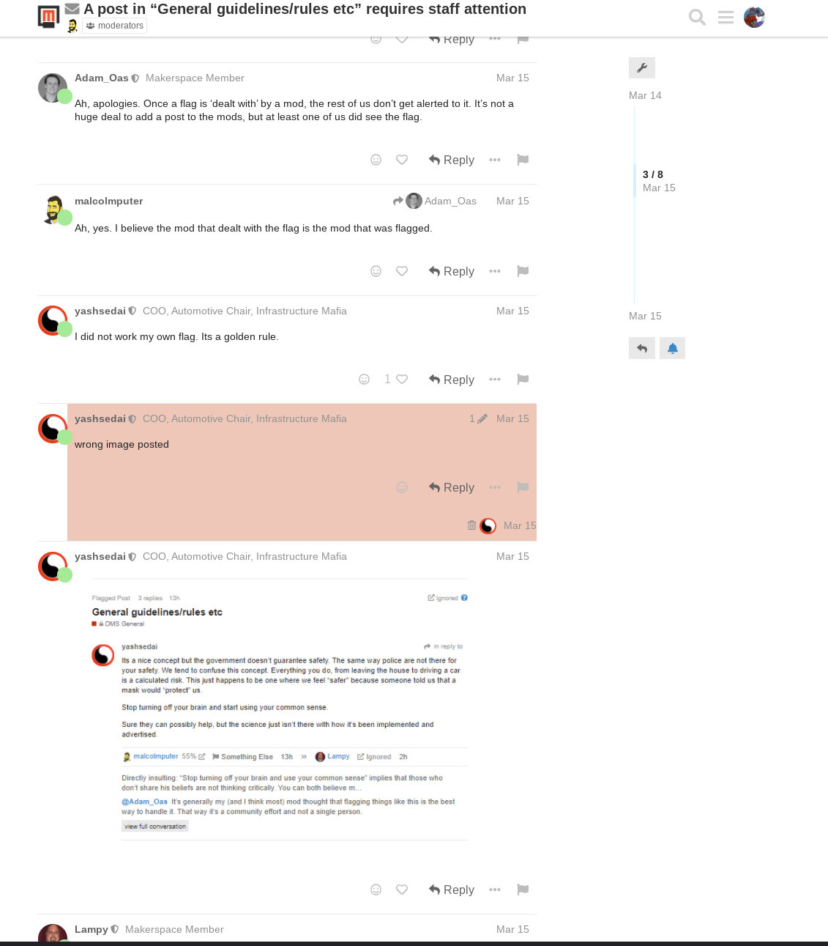

Where the image was posted

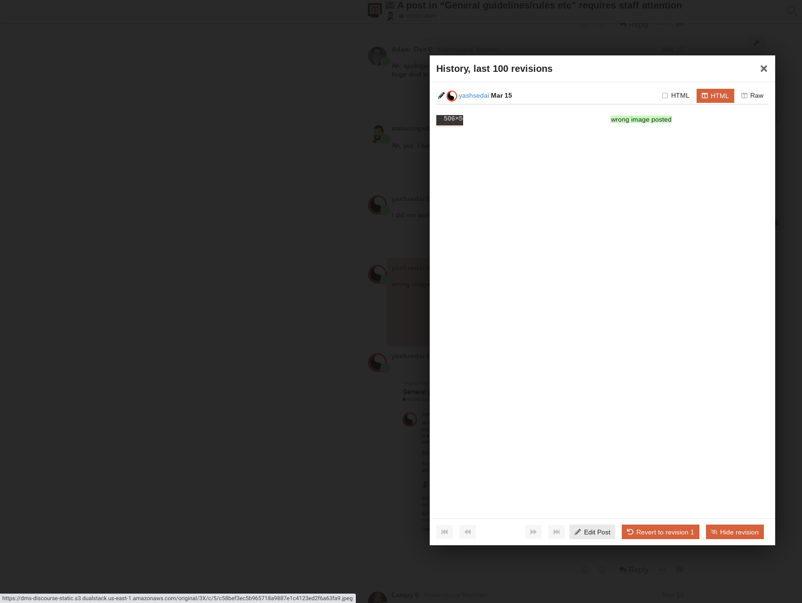

Discourse showing that the image was still supposed to be in the DB, and containing a link to its location. This proves that the software did not “prune” the image and it was hidden on a backend

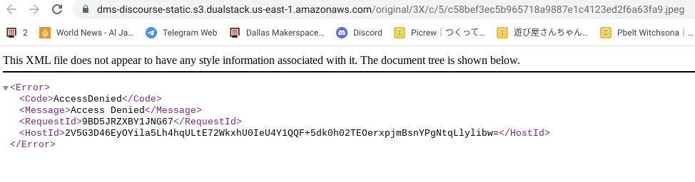

Image was Removed or the ACL changed to hide its contents via the AWS S3 system backend

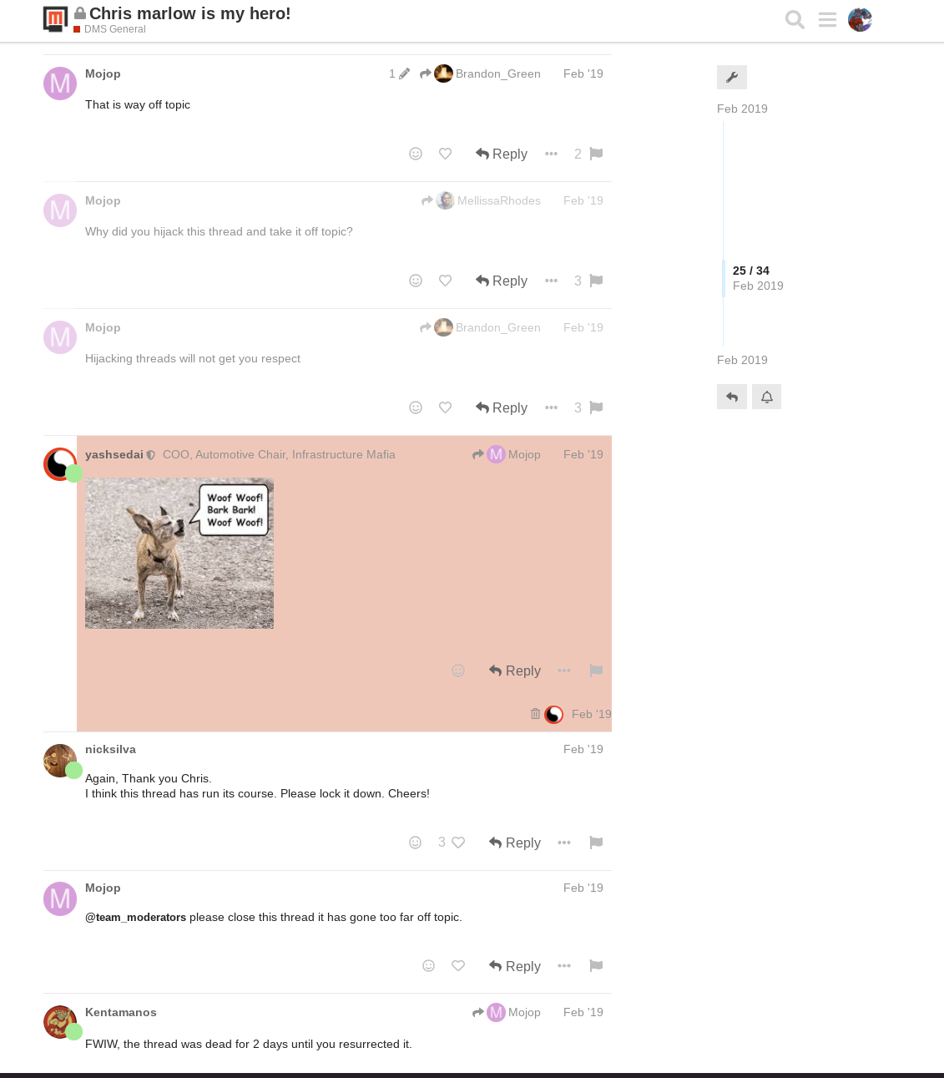

Sample post showing that Images are not deleted as part of the post deletion process, confirming someone had tampered with the talk backend to hide it

Continuing from this point, with the knowledge of his true thoughts on my identity known, Freddy became more direct in his actions.

The next notable incident was during Pride month, in which DMS promotes Pride and I was visibly a board member who was LGBTQ+. During this time, I was cornered twice by Freddy in the common area demanding an explanation for either my identity, or why businesses should provide tangible support for LGBTQ+ groups.

Freddy is a very imposing person physically, is presumed by most members to be armed based on his known carry and gun stances through talk posts and statements about it in person, and is known for being constantly allowed off the hook for aggressive behaviour with no consequences.

Needless to say, these present moments of serious panic. At the time I had no idea what to do, and was more concerned with ensuring that I always had a way out from a physical confrontation. Due to fears of retaliation nothing was said at the time for these incidents and the severity as, due to the previous unwillingness to prevent him from digging in even more, he sees all at DMS and is perceived as being untouchable.

These were likely witnessed by TKTK-1 and TKTK-2.

For some perspective on thoughts from the membership, other LGBTQ+ members immediately messaged me asking if it was Freddy when I posted publicly, despite trying to keep the identity private as a matter of course but having no other option than to speak out at all. This perception is not solely mine. Witness TKTK-5 and TKTK-6 can speak to this perception.

After Pride month, Freddy began to escalate his personal attacks to interfere with our work once again. Despite the claims that it is simply a “difference in opinion” on several matters, he has admitted in writing falsifications he spreads about me around the shop, and witnesses Shay Galland and Art Givens were present when he admitted to continuing to spread false information even when confronted with physical evidence. This has increased tensions in other committees, such as the metal shop, as he spreads these rumors about, and I quote, “have a hard on for metal shop” despite knowing that, based on facts, the information he often spreads is wrong.

He continues to use this phrase to belittle my gender at every turn, in addition to continuing to call me Jim in all of these arguments and back-room rumor mills.

On top of the written acknowledgement that he continues to spread false information about my motivations under the guise of “difference in opinion,” the argument became blunt when it was brought up in the back parking lot he was doing so because of my identity. The response was a rave about “being a snowflake” and “still having a hard on for metal shop,” in addition to continuing to spread the false statements about my actions involving various matters and indicated they would continue to do so.

In the words of Freddy to me, in various of these arguments where he admits he personally does it because of me *as a person* rather than a difference in opinion, “get fucked” was the end of the argument along with the “RRRRREEEEEEEEE” thing he is known for doing before driving off.

After witnessing this incident, Shay tried to become more involved and I thank her for trying to be supportive since the incident. It is my understanding she tried to become even more involved after she found out that the incident had been ignored in my public post.

Interestingly, Art Givens has testified that, despite the board’s public claims that the incident had been investigated and witnesses spoken with, the board did not in fact talk with him until well-after these statements. Art has stated that this call was on Saturday, November 6th of 2021.

This put the interview over a month after the formal complaint about the incident was filed, and explicitly out of memory to recall more specific details. However, the board had already put into private writing that the incident investigation was ignored based on their biased opinion on what they perceived was going on, and their public statements of interviewing witnesses before this time despite no such interviews having taken place nor evidence requested.

# Explicit examples of falsifying rumors due to personal bias against me

*Note, this section is a work in progress as I compile everything*

Freddy has repeatedly claimed multiple actions of mine are “due to a hard on” for one thing or another, and that I was exceeding my authority as a board member or as the CTO for items that occurred during that time. By intentionally spreading these rumors, knowing they are false, Freddy has been proceeding with character assassination and causing attiditional tensions with other members within various committees.

The door.

*I will prefix this with the fact that the door is either open or closed is not the source of the complaint, but the rumors and false statements about me that Freddy has, and continues, to spread regularly. Personally, I couldn’t give a damn what the final decision on the door is as long as a conversation was legitimately had.*

*But these false rumors contributed to escalating the tensions between us, myself and members of metal shop, and more.*

The most visible recent event, in which he admits he is spreading these statements despite all facts stating otherwise, is the machine shop door.

Freddy has been bad mouthing me that I closed the door of my own volition, that it’s “just my opinion” or that I have a hard on for it. To defend claims that he is lying about my position, he has spread false rumors of the machine shop leadership (naming Tim and Charles specifically) as complaining about my behaviour to various individuals for locking the door. On the contrary, when pointed out that Tim had sent me the request, in writing, to re-close the door after it had become unblocked, Freddy continued to spread these false rumors.

He has falsified to people that I did it of my own volition, falsified that the door wasn’t blocked to begin with, falsified that as the CTO I had no authority to lock the door per the plans provided to the city when requested to do so after it became unblocked on accident (whilst debatable as a logistics vs infrastructure matter, at the time the board was in concurrence that it was up to the CTO and no involvement was required).

Freddy continues to spread the false statements that it was never even on the plans to the city, despite every available copy showing so.

In his continued attempts to assassinate my character, Freddy has been causing additional strain between myself and other members within metal shop and machine shop.

The following is an excerpt from September 7th, 2021. At this time Freddy is confirmed to acknowledge that the machine shop door was, in writing, requested to be closed by the committee.

It is further explained in this conversation the events of closure and that the recent one was only a “reclosing” after it had become unblocked again. This conversation proves that, contrary to what Freddy keeps spreading about me, he is aware that his statements about me to others are false.

Regardless of a difference in opinion, it is this falsification of the background of the matter to simply being a “hard on” that I supposedly have for the door that he has been using to undermine my ability to maintain stable relationships with committee leaders and members in general.

The continuance of spreading the false rumor of being the one to close the door and the committee members not desiring it can be validated by Shay Galland and TKTK-4 from the incident in the back parking lot on October 3rd, 2021 where he professed that he still tells everyone that I continue to have a “hard on” about the door and that there was never anything from the committee asking for it.

The continued use of a “hard on” to this day for describing everything is a slap in the face to my identity, on top of being false statements about my actions and the background behind them.

| [3:42 PM] yashsedai: I'm not ever gonna acquiesce to this insanity  [3:42 PM] yashsedai: Because it's you being pedantic about it when the rest of the folks I've talked to haven't an issue  [3:42 PM] yashsedai: Tim and Charles included  [3:43 PM] hon1nbo: Funny, Tim's the one that wants it closed and the two of them wanted to even block its egress  [3:43 PM] hon1nbo: at least that's what Tim kept telling me  [3:45 PM] hon1nbo: he's even the one that put in the formal request to close it that started all of it.  [3:45 PM] yashsedai: Oh?  [3:45 PM] yashsedai: Formal?  [3:45 PM] yashsedai: Writing?  [3:45 PM] hon1nbo: "Good afternoon all,  I know you all have your hands full. I thank you for your time in reading this.  I would like to request that the pass through door be closed. I will be the first to admit that it will be missed. The convenience of having the door there is great. However I feel that the inherent risks are greater for those whom proceed through the doorway. Machine Shop folks have always pressed for safety, this has been extremely hard for us to enforce in the past with people walking through our committee space without proper PPE. With the door remaining open, that will be equally difficult to enforce. We have a grinder, aluminum cold saw as well as a work table with no telling what people will be working on. The risk for an eye injury or an injury caused by not having the proper footwear, in my opinion, is high.  As to the closing of the door, we can remove the handle & install an escutcheon to prevent it from being opened.  Now with that said, we have always intended on putting a short dividers to keep chips contained inside the machine shop along the main walkway. This will be behind all the heavy equipment. During tomorrow’s committee meeting, I will be discussing & proposing that the upper portion of that divider is made of acrylic or some other clear material that can allow those walking by to be able to remain safe, while still having visibility into machine shop.  Again the Goal of all this is to have a safer space." |
| --- |

# Falsifying Various Details about me and intentionally escalating situations

Freddy has repeatedly escalated matters by spreading the notion that I am not abstaining from voting on metal shop matters.

## General discussions about metal shop

On a regular basis, Freddy informed people that I had a conflict of interest despite having already committed to abstaining from any vote. In these arguments, Freddy continues to state that the “Chris Fazio of Metal Shop” did not have anyone who agreed with the behaviour of the shop, that I am ineligible to discuss any of it (despite no rule preventing any member from asking for any accountability), and continued to deny the status of abstaining.

Witnesses for these statements, across multiple instances, include Shay Galland, TKTK-3, and TKTK-4, and TKTK-8.

## The welder escalation

As seen in these screenshots, Freddy took a discussion about a new welder for purchase (a discussion that we *are required to have* for major votes, and historically we have always rejected said votes if that discussion did not take place). Freddy continued to publicly state that I had not recused myself from the matters in Actions of the Board despite being party to earlier board conversations where it was stated, and acknowledged by the group, that I was abstaining from formal action.

This is in addition to attempting to *gaslight* me in the same thread by claiming a discussion had happened by taking a post out of context to try and claim that a discussion had in fact occurred, despite that it had not.

Every member has a right to hold committees accountable, and as a board member I have every right to seek information and what is going on in the stead of members who wish to remain anonymous, even if I will not vote in any actions at any level.

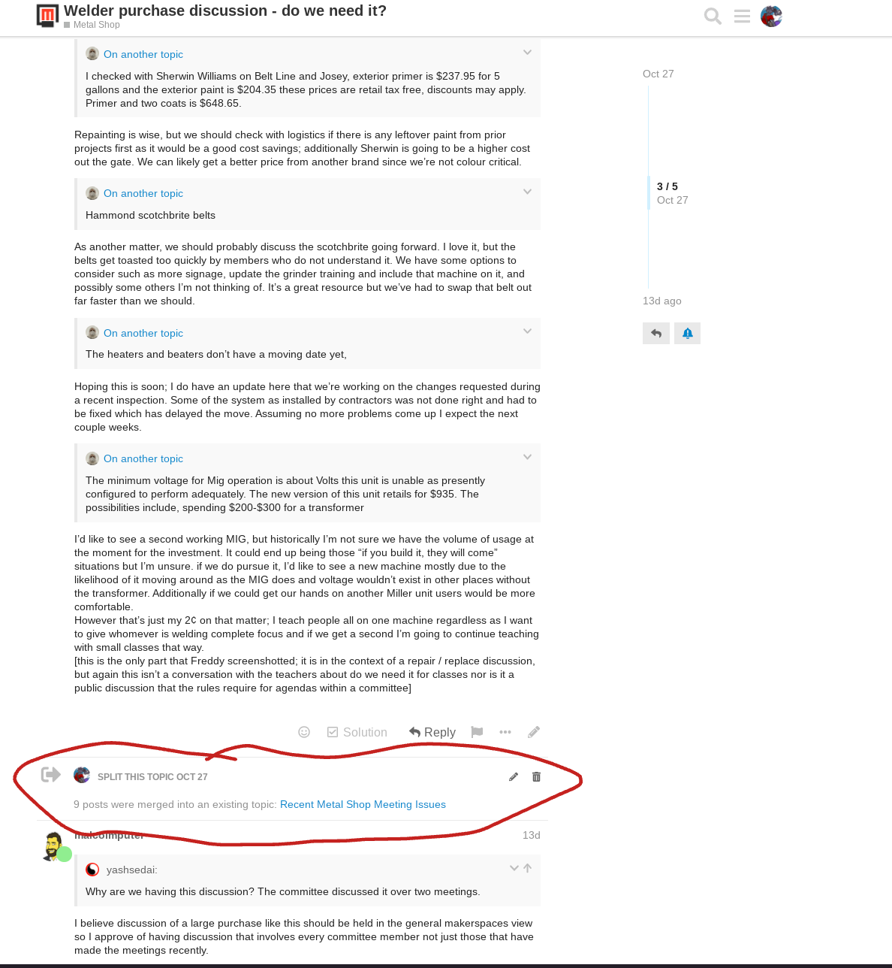

Freddy hijacking a required discussion to personally attack me. It additionally shows I moved the posts to try and keep the welder discussion on track

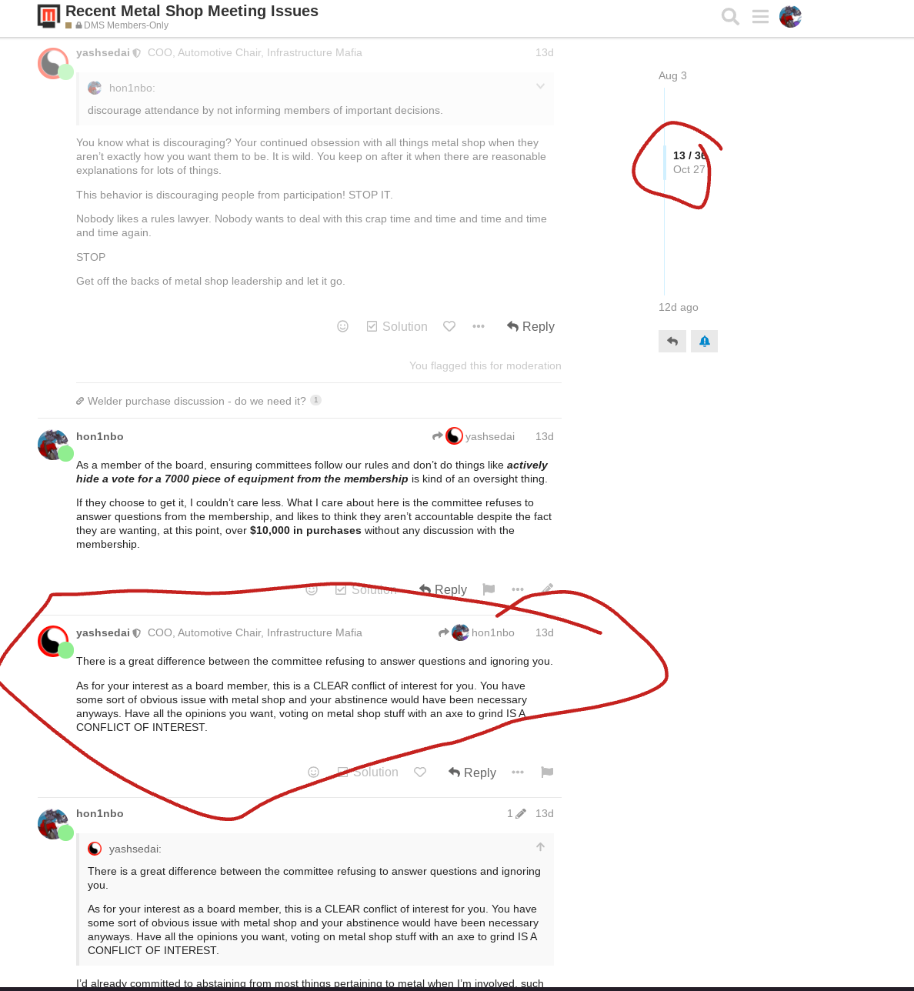

Freddy continuing to falsely state in public that I had not already recused myself from any Action of the Board

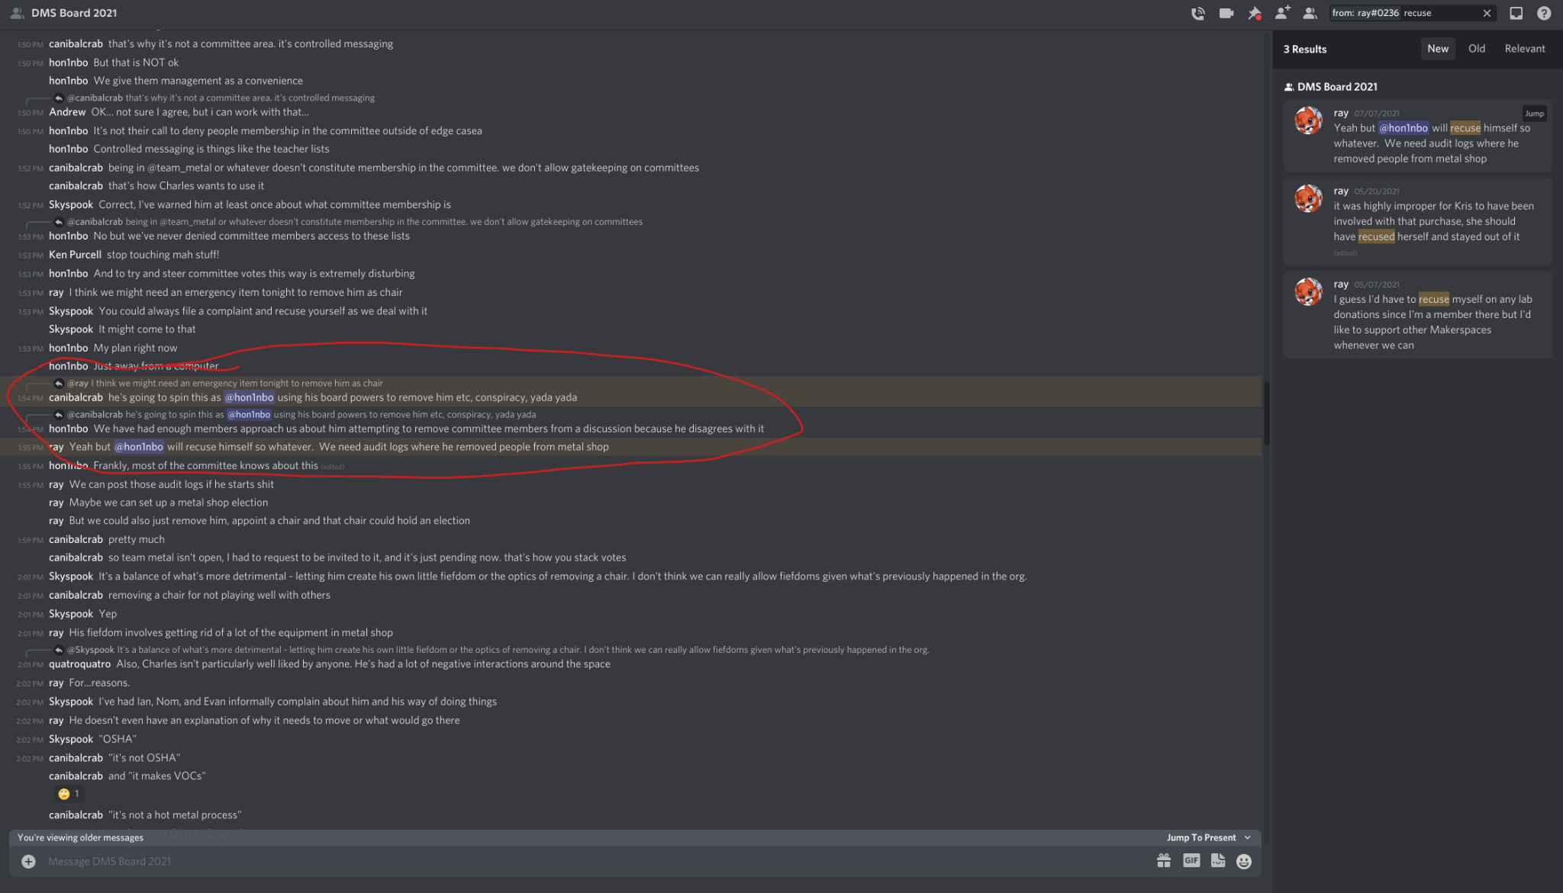

Screenshots of DMS Board 2021 discord channel showing acknowledgement that I abstained from all metal shop matters by the Secretary and board members

## Falsifying My Moderation History on Talk

Freddy continued his harassment of me when Andrew Spender re-instated my talk moderation status. Andrew, being the officer with sole authority outside a formal action of the board, was not consulted before my accounts were disabled. Ironically, Freddy’s accounts remained despite being the subject of a serious complaint.

When Andrew reinstated my account, Freddy messaged infrastructure falsifying my moderation history, claiming that I regularly acted on threads involving myself or subjects of my complaints with a specific note claiming that I have been acting even more “as recent as this month of working their own flags.”. As shown in the screenshots below his Discord rant in the infrastructure channel, my moderation history for the past two months shows that no such self-moderation has taken place.

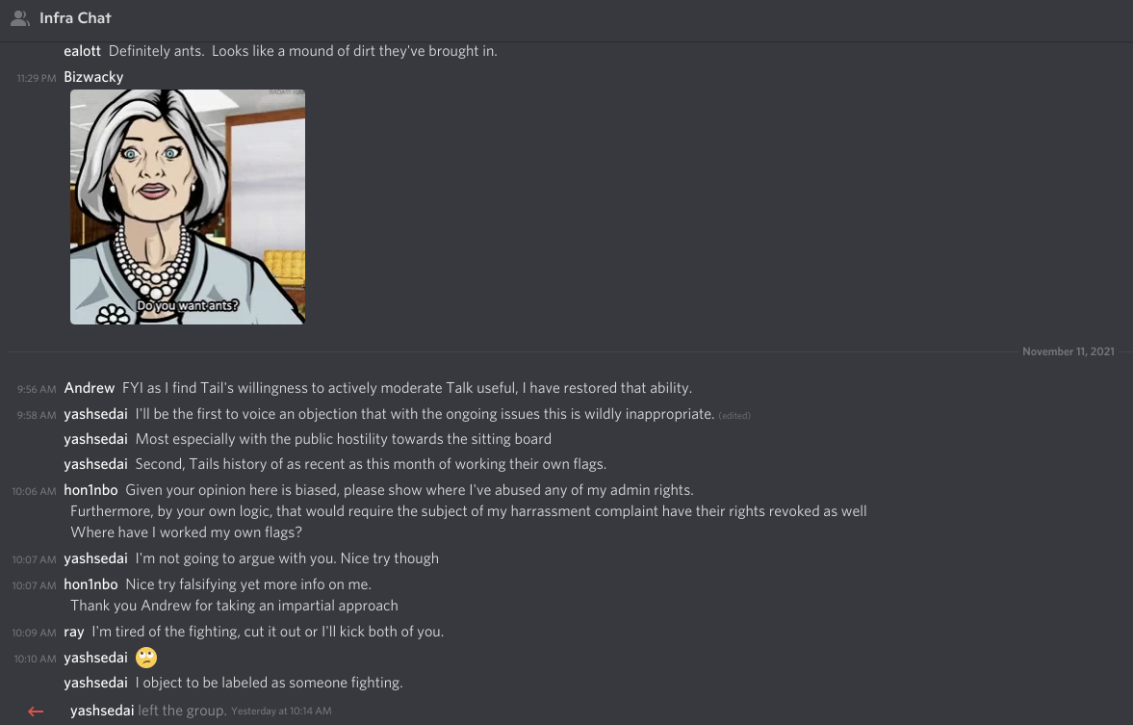

Freddy continuing to falsify information about me

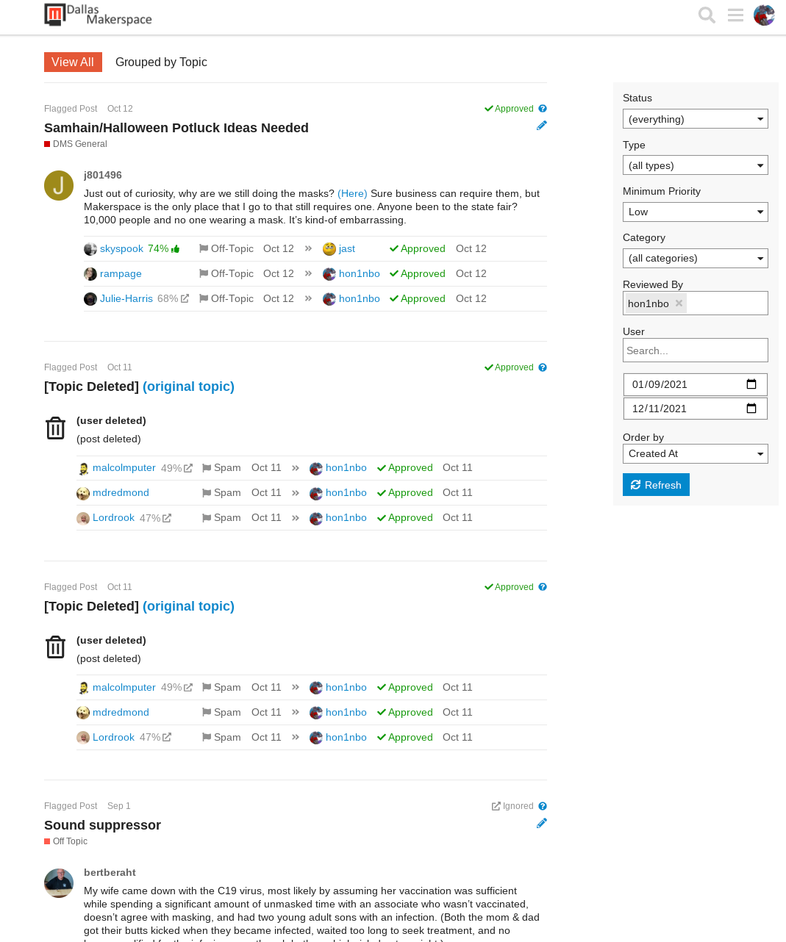

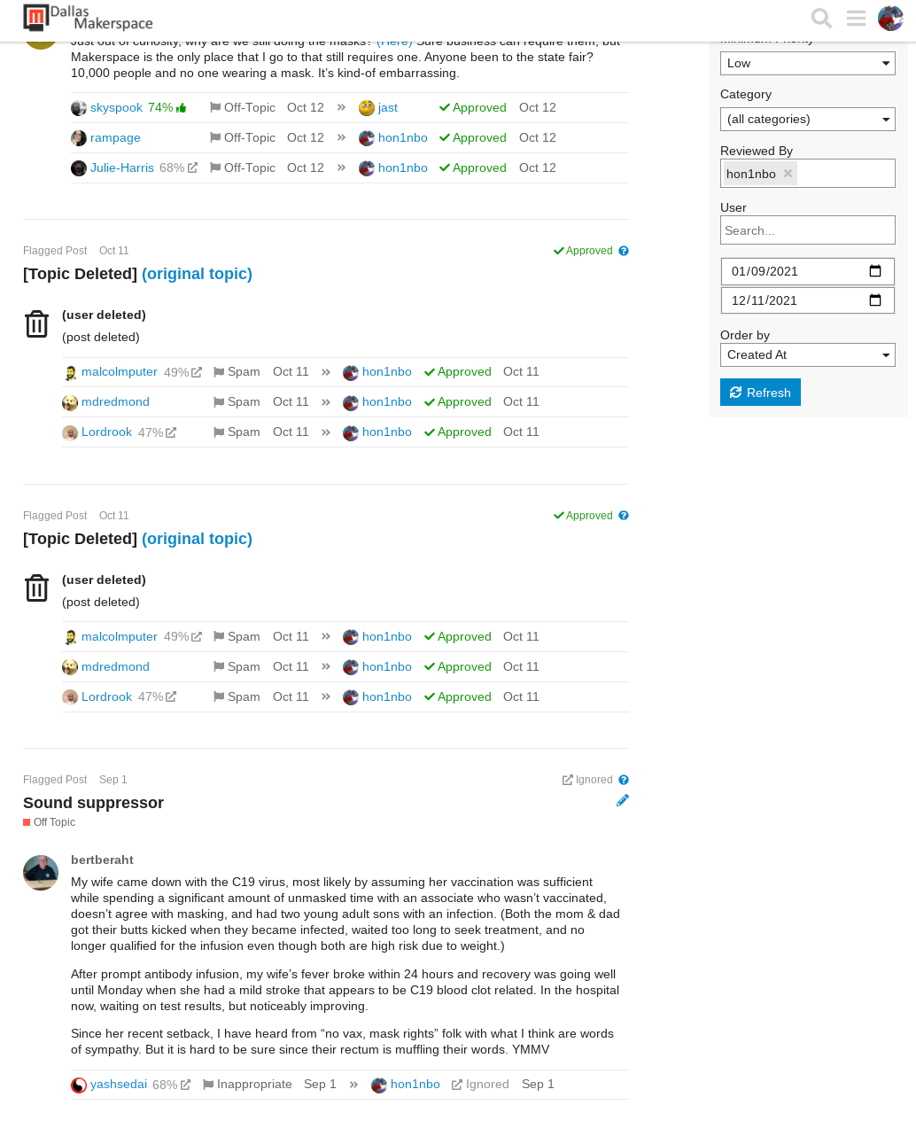

Two months worth of my talk moderation history show that Freddy has been falsifying more information about me